
American International University-Bangladesh (AIUB)
Department of Computer Science
Faculty of Science &Technology (FST)
Fall 25-26
A Hyperlocal Online Shopping System Connecting Customers with Nearby Stores for Same-Day Delivery
Software Requirement Engineering
Sec: A
Project submitted By

Md Mujtahid Hassan (22-47427-2)

Checked By Industry Personnel (Optional)

Name:

Designation:

Company:

Sign:

Date:

- PROBLEM DOMAIN
  - Background to the Problem
The demands of consumers for ease, quickness, and flexible delivery options are changing dramatically because of e-commerce's phenomenal rise. Centrally controlled warehouses, national merchants, and multi-day shipping processes are the main features of traditional e-commerce platforms. Although these systems work well for large-scale distribution, they often fall short in supporting local retail ecosystems and do not completely satisfy the need for same-day completion and immediate product availability. At the same time, a lot of local shops still rely on manual inventory management, in-person sales, and a small internet presence, which limits their capacity to compete with bigger online merchants.

Local business practices are currently dispersed in the actual world. Consumers often visit several local stores to evaluate prices and availability, which is inefficient and time-consuming. Some merchants use third-party delivery services or independent web listings, although these options are frequently expensive, disjointed, or have limited coverage. Current local delivery platforms frequently lack consistent pricing, real-time inventory information, and smooth customer, retailer, and delivery staff coordination. Order cancellations, delays, and erroneous product availability are therefore still frequent problems.

Several underlying issues related to operational restrictions, technological limitations, and institutional inefficiencies give rise to the difficulties found in the present-day hyperlocal commerce environment. Together, these underlying issues make it difficult for current solutions to efficiently offer same-day delivery services and real-time local shopping. The following lists is the some of main underlying reasons of the issue:

- lack of a single, integrated platform that allows customers and local shopkeepers to communicate digitally in real time.
- Small and medium-sized merchants lack the infrastructure, knowledge, and technological resources necessary to create, implement, and manage autonomous e-commerce platforms.
- Hyperlocal operational requirements, such as same-day delivery, short-distance logistics, and location-based order fulfilment, are not adequately supported by current e-commerce platforms.
- Inaccurate product availability and ineffective order processing are caused by a lack of real-time inventory visibility at the store level.
- The usage of third-party services that don't facilitate smooth communication between delivery operations, retailers, and customers.
- loopholes in technology that prevent local companies and customers from working together effectively and exchanging data.
  - Solution to the Problem
1.2.1 Proposed Solution
The development of a Hyperlocal Online Shopping System, which digitally links consumers with local retail establishments and permits same-day delivery via an integrated, real-time platform, is the suggested remedy. By offering a unified solution that connects customers, local retailers, and delivery operations, the system is intended to solve the underlying reasons of inefficiencies in local commerce.
Instead of dealing with surface-level problems like poor store visibility or delayed deliveries, the approach directly addresses fundamental issues by:
- Providing exact product availability and discovery through real-time connection between customers and local retailers.
- Removing the need for each shop to create and manage distinct e-commerce systems by providing a centralised digital platform.
- Supporting hyperlocal operational needs, such as short-distance logistics, same-day order fulfilment, and location-based retailer discovery.
- Facilitating regular coordination and communication between delivery staff, retailers, and customers.
- The approach tackles the inefficiencies of dispersed third-party services, the lack of integration, and the technological obstacles small businesses confront by combining various operations into a single system.

1.2.2 Justification of the Proposed Solution
- Efficiency: By automating order placement, inventory updates, and delivery coordination, the system minimises manual labour and operational delays while streamlining the entire shopping and delivery process.
- Cost-Effectiveness: Small and medium-sized businesses can take part without having to spend money on independent e-commerce infrastructure. Development, upkeep, and operating expenses are decreased by shared platform resources.
- Ease of Implementation: The system makes use of widely used technologies, including location-based services, digital payment gateways, online and mobile applications, and conventional database systems, to ensure simple development and implementation.
- Scalability: Without requiring significant modifications to the system design, the platform may be gradually expanded to accommodate more retailers, users, and delivery agents.
- User Acceptance: The system is acceptable and advantageous to all stakeholders since customers enjoy convenience, quicker delivery, and access to local goods, while retailers gain greater visibility and digital reach.
1.2.3 Feasibility and Business Alignment
The suggested method fits in nicely with current business and market practices and is operationally realistic. The viability of such systems is already demonstrated by the usage of hyperlocal delivery models in on-demand logistics, supermarket services, and food delivery.
From a business standpoint, the system helps achieve important goals by:
- Increasing client satisfaction through dependable local availability and quicker fulfilment.
- Making it possible for regional merchants to more successfully compete with major online businesses.
- Promoting environmentally friendly local business without interfering with current retail operations.
- Seamlessly integrating with contemporary procedures like local delivery services and in-store inventory management.

Businesses may implement the system gradually thanks to its modular design, which minimises interruption and maximises operational value.

1.2.4 System Overview

A hyperlocal online shopping platform that enables same-day delivery from local retail establishments is the software solution being described. Its main goal is to provide consumers with a single digital interface for finding, ordering, and receiving goods from nearby retailers.
Core objectives of the system include:

- Utilising geographic location to link customers with local businesses.
- Supplying pricing and product availability data in real time.
- Assisting with placing, processing, and delivering orders on the same day.
- Providing local retailers with an easily accessible online shopfront.

Expected benefits include:
- Quicker shopping times and more client convenience.
- Greater online visibility and more chances for local shops to make sales.
- Enhanced local delivery operations' efficiency and coordination.

Target users of the system include:
- Customers looking for quick and easy local purchasing options.
- Owners of small and medium-sized retail stores.
- Delivery staff or delivery services provided by partners.

1.2.5 Existing Solutions and Industry Alignment

By providing location-based ordering and last-mile delivery through grocery stores, local marketplaces, and on-demand delivery applications—including food delivery services like foodpanda, which make use of mobile applications, GPS-based tracking, and digital payment technologies—several current platforms address aspects of hyperlocal commerce. However, local shops have less flexibility because these solutions are sometimes restricted to industries or significantly rely on third-party logistics. By supporting a wider range of retail categories, facilitating closer interaction with local shop operations, and placing an emphasis on real-time inventory accuracy, the suggested system expands upon existing tried-and-true methods. This strategy offers a more complete, scalable, and sustainable solution that satisfies the demands of regional companies as well as contemporary consumers.

2. SOLUTION DESCRIPTION

2.1 System Features
The Hyperlocal Online Shopping System offers a unified, web-based platform facilitating real-time engagement among consumers, local retailers, and delivery services. The system's features are meticulously crafted to optimize efficiency, precision, scalability, and user-friendliness, thereby enabling same-day hyperlocal commerce.

2.1.1 Customer Interaction and Ordering Feature
Functional Requirements:
• The system shall enable customers to safely register and log in.
• Based on geographic location, the system will enable customers to find local retail establishments.
• Customers shall be able to peruse merchandise from specific local retailers through the system.
• Real-time product availability and pricing shall be displayed by the system.
• Customers shall be able to place orders for same-day delivery through the system.
• Customers shall be able to place distinct orders from several nearby stores using the system.
• Customers shall be able to view order status updates through the system.
• Following the completion of an order, customers shall be able to rate and comment on the system.
Qualities of Quality:

• Usability: All user types should find the interface simple to use and intuitive.
• Performance: Order placement and product browsing must be completed quickly.
• Reliability: Information about product availability and order status must be correct.
• Security: Transaction and customer data must be safeguarded.

2.1.2 Features of Retailer (Shop) Management
Functional Conditions:
• Local retailers shall be able to register and set up online storefronts through the system.
• Retailers shall be able to control product listings and prices thanks to the system.
• Real-time store-level inventory updates shall be supported by the system.
• The system shall instantly inform retailers of any new orders.
• Orders shall be accepted, processed, or rejected by retailers using the system.
• Retailers shall be able to update the order fulfillment status through the system.
Quality Attributes:

• Efficiency: Order processing and inventory management processes must be optimized.

• Scalability: An increasing number of retailers will be supported by the system.

• Reliability: Changes in inventory must be reflected uniformly throughout the platform.

• Security: Store data and retailer accounts must be shielded from unwanted access.

2.1.3 Order Processing and Delivery Coordination Feature
Functional Requirements:

• The system shall facilitate order fulfillment between delivery staff and retailers.

• Within a specified hyperlocal range, same-day delivery must be supported by the system.

• Through order status updates, the system shall enable customers to monitor the status of deliveries.

• Using location-based services, the system shall enable real-time delivery tracking.

• The system shall alert clients at critical points in the delivery process.

Qualities of Quality:
• Availability: Order status information and delivery tracking must always be available.
• Accuracy: Real-time order progress will be reflected in delivery updates.
• Performance: Notifications must be sent out as soon as possible.

2.1.4 Administrative Management and Monitoring Feature
Functional Requirements:
• The system shall enable administrators to oversee delivery, retailer, and customer accounts.
• The system shall enable administrators to keep an eye on every order and delivery.
• The system shall enable administrators to manage complaints and disputes.
• Reports on sales, delivery performance, and system usage shall be generated by the system.
Quality Attributes:

• Maintainability: It should be simple to set up and update administrative features.

• Reliability: System logs and reports must be precise and consistent.

• Security: Role-based and limited administrative access is required.

2.1.5 Advanced Feature: Optional Aggregated Hyperlocal Delivery

Functional Conditions:

• Orders from several local retailers may be combined by the system into a single delivery.

• To reduce delivery time and distance, the system shall optimize delivery routes.

Qualities of Quality:

• Efficiency: Delivery time and cost will be decreased through aggregated delivery.
• Scalability: Increased order and retailer volume will be supported by the feature.

2.2 UML Diagrams

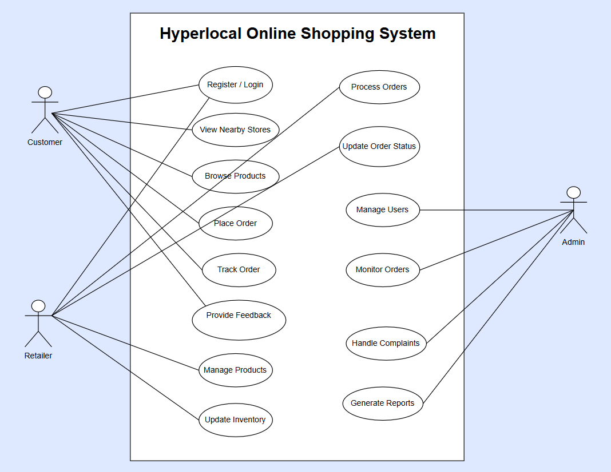
Figure 1: Use-case Diagram

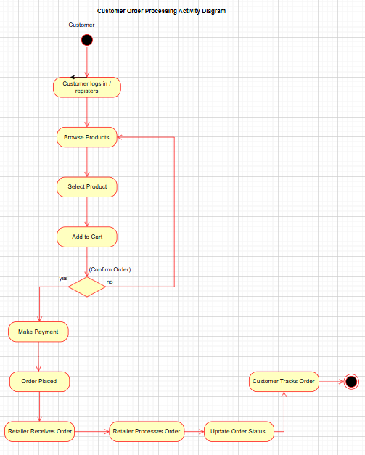
Figure 2: Activity Diagram

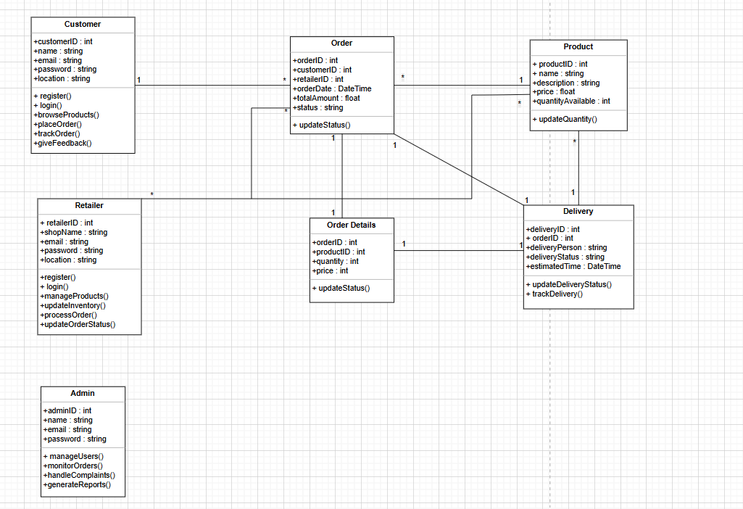
Figure 3: Class Diagram

3. Social Impact
3.1 Promotion of Local Digital Commerce
The proposed Hyperlocal Online Shopping System is expected to create significant positive social impacts across multiple dimensions. The system will promote digital commerce at the local level by enabling the use of modern technology to connect customers, local retailers, and delivery service providers through a unified platform.
3.2 Convenience and Time Efficiency for Consumers
The system will make the daily shopping process more convenient, faster, and time-efficient for general consumers. By utilizing location-based services, customers will be able to order essential products online from nearby local stores and receive same-day delivery. This will reduce unnecessary travel, save valuable time, and improve the overall quality of life for consumers.

3.3 Empowerment of Small and Medium-Sized Local Retailers
The system will serve as an important digital platform for small and medium-sized local retailers. Without the need to invest in separate e-commerce infrastructure, retailers will be able to showcase and sell their products online. This will expand their market reach and enable them to compete more effectively with large e-commerce platforms, thereby strengthening the local economy.
3.4 Employment Generation and Community Development
The proposed system will contribute to job creation at the local level. New employment opportunities will be generated, particularly in delivery services, system operations, and customer support. This will have a positive impact on reducing unemployment and supporting economic stability within the community.
3.5 Environmental Sustainability and Efficient Distribution
The use of short-distance delivery models will help reduce traffic congestion, fuel consumption, and carbon emissions, contributing positively to environmental sustainability. At the same time, the efficiency and coordination of local product distribution will be significantly improved.
3.6 Overall Social and Economic Contribution
Overall, the Hyperlocal Online Shopping System has the potential to establish a sustainable, efficient, and socially responsible digital commerce ecosystem that will make a meaningful contribution to both social and economic development.
4.Development Plan with Project Schedule
4.1 Development Plan:
Requirements Gathering (Weeks 1–2):
Identify user needs and system requirements by analyzing the functionalities of customers, local retailers, delivery personnel, and administrators. Functional and non-functional requirements are collected and documented in the Software Requirement Specification (SRS).
System Design (Weeks 3–5):
Design the overall system architecture, database schema, and user interface layouts. UML diagrams such as Use Case Diagram, Class Diagram, and Activity Diagram are created to represent system structure and workflow.
Development (Weeks 6–12):
- Front-end development for customer, retailer, and admin interfaces.
- Back-end development for user authentication, product listing, inventory management, order processing, and delivery coordination.
- Database implementation and system integration.
Testing and Deployment (Weeks 13–15):
Perform unit testing, integration testing, and system testing to ensure system reliability and correctness. After successful testing, the system is deployed in a demo or beta environment.
Maintenance and Updates (Ongoing):
Regular system maintenance, bug fixing, performance optimization, and feature updates based on user feedback and future requirements.

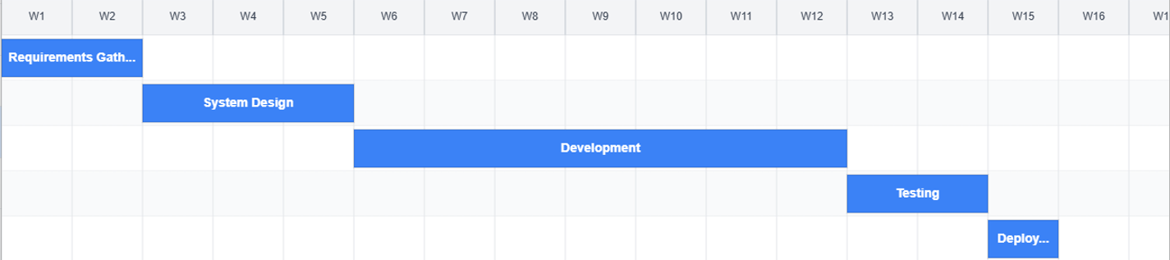
Fig 1 : Gantt Chart

4.2 Project Management Tool :
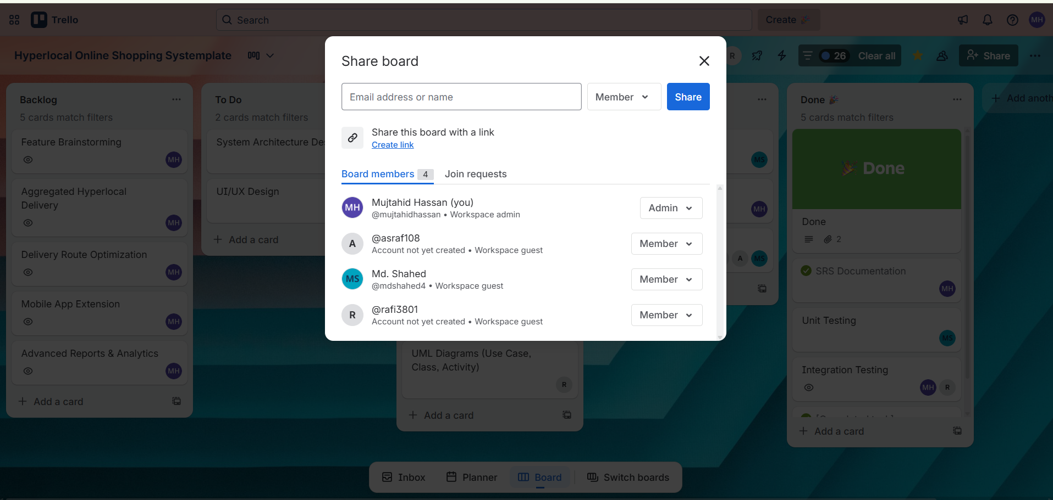
Fig 1: Trello Board Members and Role Assignment

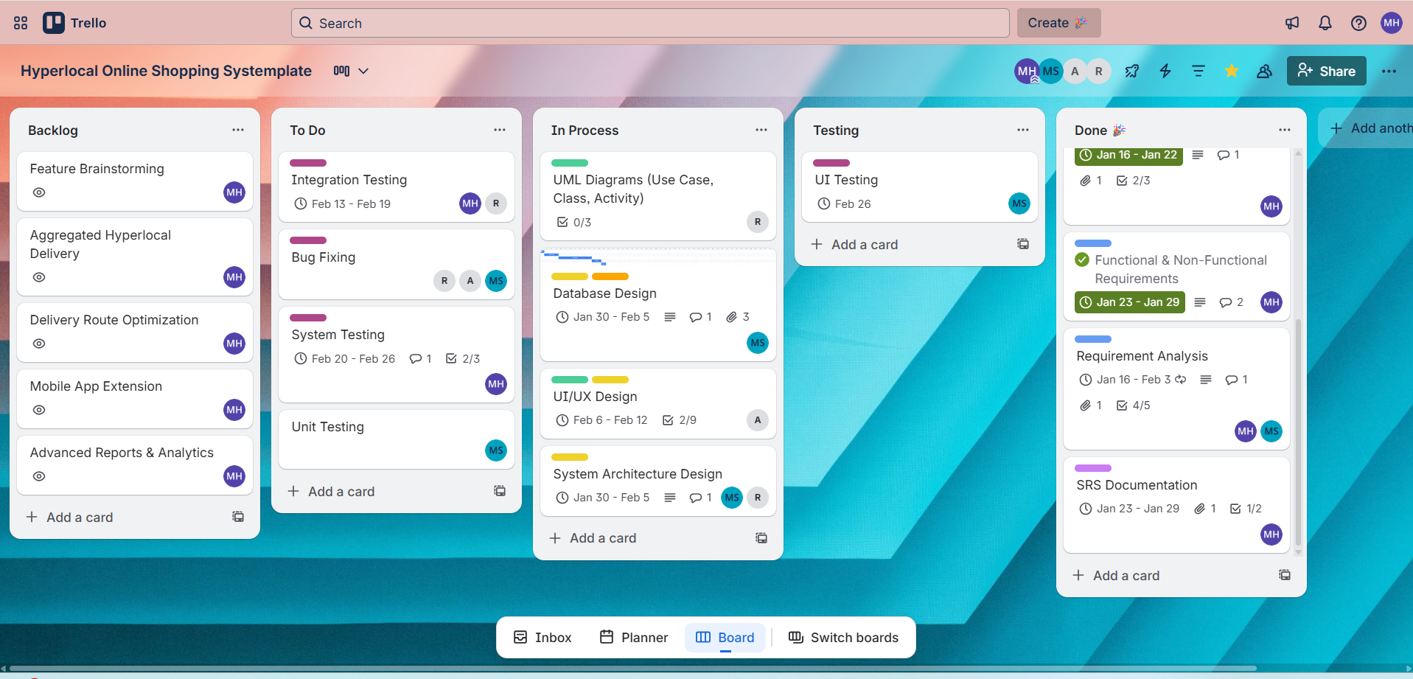
Fig 2: Trello Board Showing Project Workflow and Task Progress
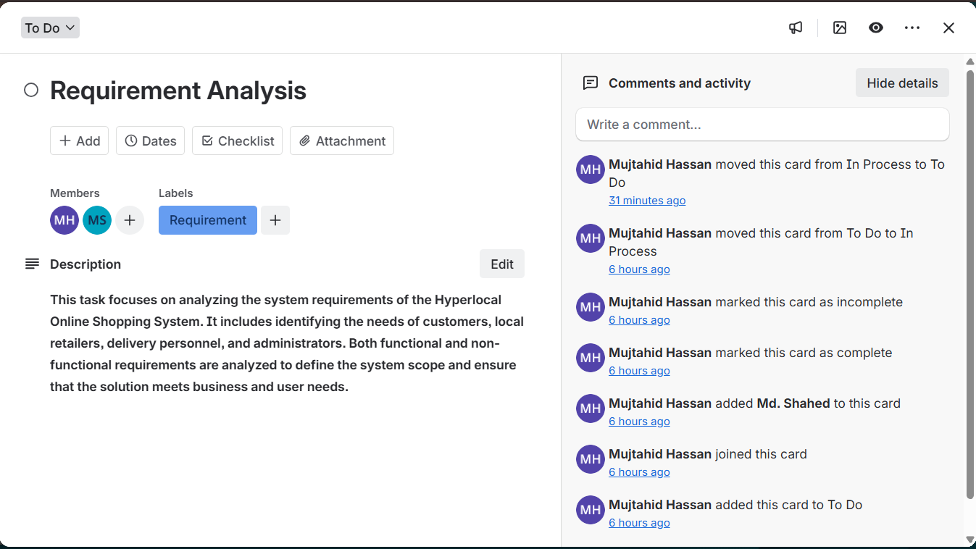
Fig 3 : Requirement Analysis Task Details in Trello
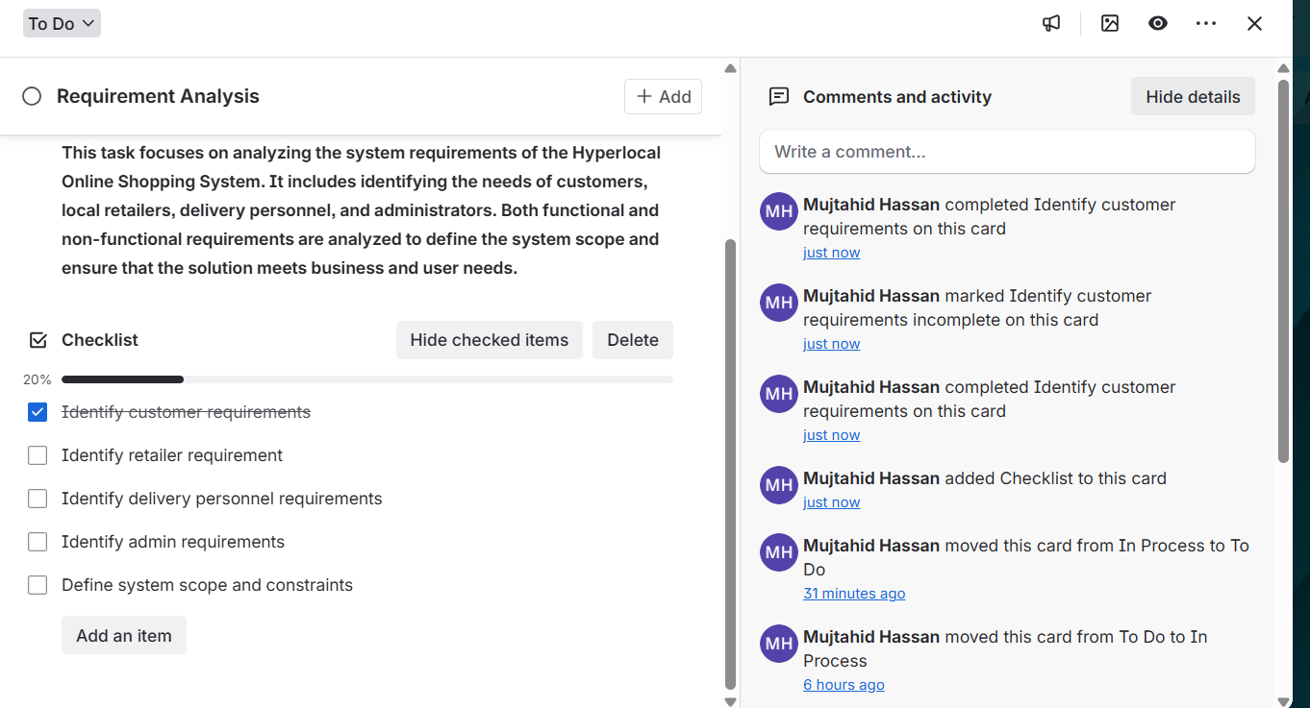
Fig 4 : Requirement Analysis Task with Checklist and Activity Tracking in Trello

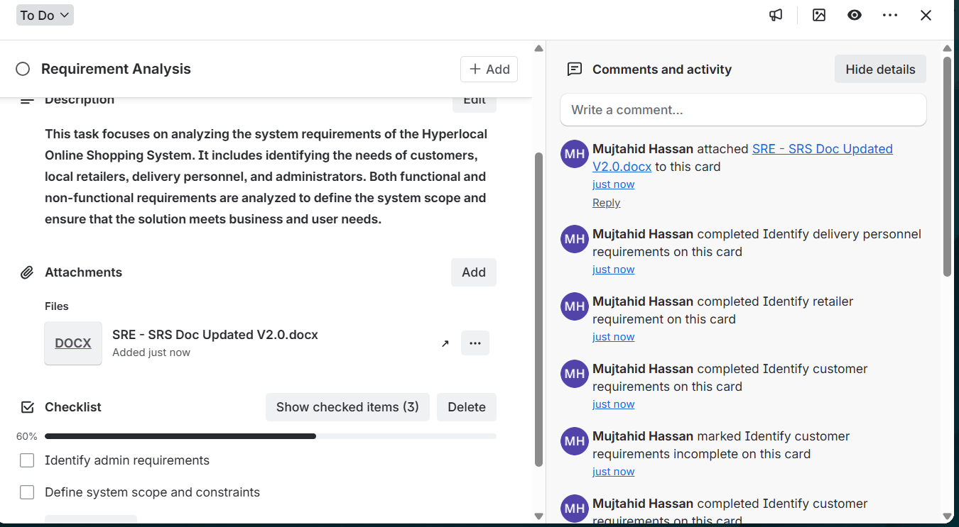

Fig 5: Trello Card Demonstrating Requirement Analysis Progress and File Attachment

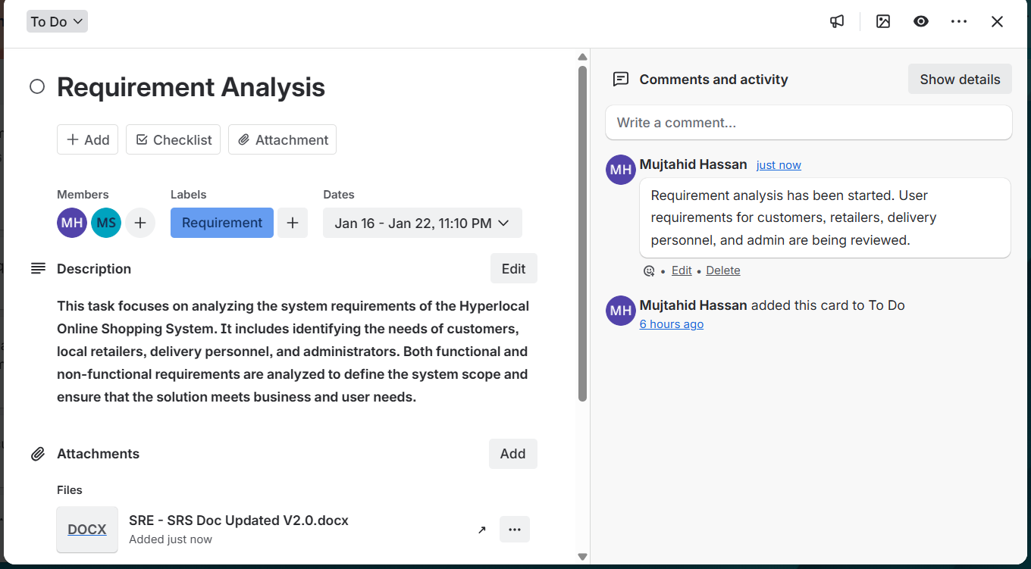
Fig 6 : Requirement Analysis Task with Comment in Trello

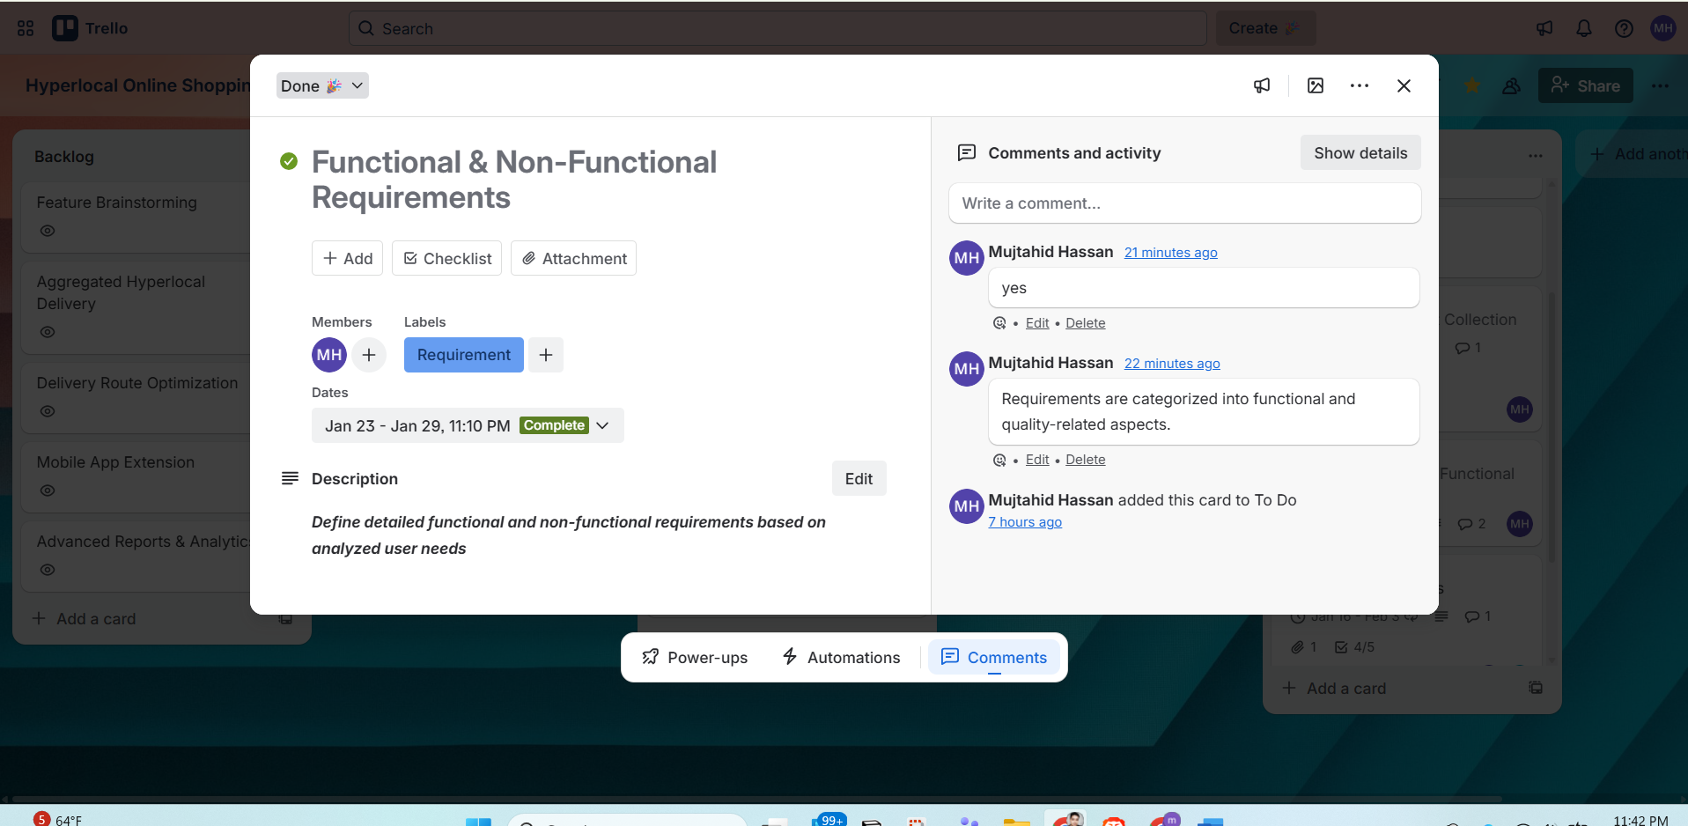

Fig 7 : Development Schedule using project management tool.

5. Marketing Plan
5.1 Marketing Objectives
- Establish the platform as the default choice for same-day local shopping within the target city or area.
- Onboard a critical mass of local retailers across key categories such as grocery, pharmacy, convenience, electronics, and fashion.
- Achieve a steadily increasing number of repeat customers and daily active users.
- Build a trustworthy brand image focused on convenience, reliability, and support for local businesses.
5.2 Target Market and Positioning
5.2.1 Target Customer Segments
- Urban and semi-urban customers who require same-day delivery of essential and lifestyle products.
- Working professionals, students, and families with limited time for in-person shopping.
- Customers who prefer to support local shops while still enjoying the convenience of online ordering and home delivery.
5.2.2 Target Retailers
- Small and medium-sized local retailers that do not have their own e-commerce infrastructure.
- Stores that already have consistent physical customer flow but want to expand their reach through digital channels.
- Retailers interested in structured inventory management, order tracking, and data-driven decision-making.
5.2.3 Positioning Statement
The platform is positioned as a hyperlocal marketplace that combines the speed and convenience of modern e-commerce with the trust and familiarity of neighborhood stores. It enables customers to receive same-day delivery from nearby shops through a single unified application, while helping local retailers extend their digital presence and increase sales.

5.3 Short-Term Marketing Plan (Launch to First 6 Months)
The short-term marketing plan focuses on launch activities, awareness creation, and rapid user acquisition in a limited geographic pilot area.
5.3.1 Key Activities
5.3.1.1 Pre-Launch and Launch Campaigns
- Execute teaser campaigns and countdown posts on social media platforms targeting users within the pilot area.
- Announce launch offers such as free delivery or reduced service fees for a limited number of initial orders.
- Share clear instructions and short explainer content that demonstrates step-by-step ordering from nearby stores.
5.3.1.2 Retailer Onboarding Drives
- Conduct direct visits to prospective partner shops in the pilot area to explain the platform’s benefits.
- Offer limited-period incentives such as reduced or zero commission for early adopter retailers.
- Provide in-store promotional materials, including posters, counter stands, and QR codes to promote the application.
5.3.1.3 Customer Acquisition Campaigns
- Run location-based digital advertisements that target residents and workers within the delivery radius.
- Introduce promotional codes for first-time users, such as discounts on their first order or referral bonuses.
- Collaborate with universities, offices, and residential complexes to organize demonstrations and registration drives.
5.3.1.4 Branding and Awareness
- Develop a professional brand identity, including logo, color palette, and typography, and apply it consistently across all touchpoints.
- Produce short explainer videos that demonstrate how the platform works from installation to order completion.
- Highlight the dual value proposition of convenience for customers and growth opportunities for local retailers.

5.3.2 Short-Term Success Metrics
- Number of retailers onboarded in the pilot area.
- Number of application downloads and successfully registered customers.
- Number of first-time orders and the average cost of acquiring each new customer.
5.4 Long-Term Marketing Plan (6 to 24 Months)
The long-term marketing plan emphasizes sustainable growth, brand strengthening, and expansion to new geographic areas once the core product is stable and early traction is achieved.
5.4.1 Key Activities
5.4.1.1 Geographic Expansion
- Extend delivery coverage gradually from the initial pilot area to additional neighborhoods and cities.
- Implement structured retailer acquisition campaigns for each new area, using success stories and data from the pilot region.
- Adapt marketing messages and promotions to local cultural and seasonal contexts to increase relevance.
5.4.1.2 Partnerships and Collaborations
- Collaborate with payment gateways, digital wallets, and banks to offer cashback, discounts, and co-branded campaigns.
- Partner with corporate offices, hostels, and residential communities to handle recurring bulk orders and scheduled deliveries.
- Work with local courier and delivery service providers to supplement in-house capacity during high-demand periods.
5.4.1.3 Brand Building and Differentiation
- Continuously refine brand messaging around supporting local shops, real-time availability, and same-day convenience.
- Publicize case studies of retailers who achieved measurable sales growth through the platform.
- Participate in local events, fairs, and community activities to reinforce trust and visibility.

5.4.1.4 Customer Retention and Upsell
- Implement loyalty programs that reward repeat purchases with points, credits, or exclusive offers.
- Use purchase history and browsing behavior to generate personalized product recommendations.
- Organize thematic campaigns such as festival sales and seasonal promotions to increase average order value and frequency.
5.4.2 Long-Term Success Metrics
- Customer and retailer retention rates over defined time periods.
- Growth in monthly active users and number of daily orders.
- Average order value and revenue per customer.
- Brand awareness and customer satisfaction indicators collected through ratings and surveys.
5.5 Continuous and Ongoing Marketing Activities
Continuous marketing activities ensure that the platform remains visible, trusted, and competitive over time.
5.5.1 Always-On Digital Presence
- Maintain active social media profiles with regular posts on offers, new store announcements, and customer testimonials.
- Optimize search visibility by using relevant local shopping and same-day delivery keywords in digital content.
- Run low-budget but continuous targeted advertisements for high-potential customer segments.
5.5.2 Data-Driven Campaign Optimization
- Monitor click-through rates, conversion rates, and cohort behavior to refine audience targeting and messaging.
- Conduct A/B testing on promotional messages, creatives, and discount structures to identify the most effective combinations.
- Use analytics dashboards to link marketing expenditure directly to customer acquisition and retention outcomes.

5.5.3 Customer Relationship Management
- Send periodic newsletters or in-app notifications that highlight new features, new retailers, and special offers.
- Analyze customer ratings, reviews, and support tickets to identify service improvement opportunities.
- Provide targeted benefits to high-value customers based on lifetime value, order frequency, and product preferences.
5.5.4 Retailer Relationship Management
- Schedule regular feedback interactions with retailers to understand operational challenges and suggestions.
- Offer training materials and webinars to assist retailers in managing product listings, pricing, and inventory updates.
- Introduce tiered benefit programs for retailers based on performance and engagement levels on the platform.
5.5.5 Continuous Success Metrics
- Net Promoter Score and average rating from both customers and retailers.
- Customer and retailer churn rates.
- Cost of customer acquisition and retention relative to projected customer lifetime value.

6. Cost and Profit Analysis
6.1 Assumptions
- Initial development duration is six months.
- Initial deployment scope covers one major city area as a pilot.
- Development is conducted by a small professional team.
- The system is deployed on scalable cloud-based infrastructure.
- Revenue is primarily generated from commission on orders, delivery margin, and retailer promotion fees.

6.2 One-Time Development Costs
6.2.1 Human Resource Costs (Development Phase: 6 Months)
The estimated human resource costs for the development phase are as follows:
Role | Effort | Rate (BDT per Month) | Estimated Cost (BDT)
Full-Stack Developer | 1 full-time equivalent for 6 months | 70,000 | 420,000
Mobile Application Developer | 1 full-time equivalent for 6 months | 60,000 | 360,000
UI/UX Designer | 0.5 full-time equivalent for 4 months | 40,000 | 80,000
Quality Assurance Engineer | 0.5 full-time equivalent for 3 months | 40,000 | 60,000
Subtotal: Human Resource Costs = 920,000 BDT.
6.2.2 Infrastructure, Tools, and Miscellaneous Costs
The estimated infrastructure, tools, and miscellaneous costs are as follows:
Item | Assumption | Estimated Cost (BDT)
Cloud hosting for development and staging environments | Eight months at 7,000 BDT per month | 56,000
Domain registration and Secure Sockets Layer (SSL) | Annual basis | 4,500
Development, design, and collaboration tools | Six months at 3,000 BDT per month | 18,000
User research and testing incentives | Surveys and pilot user groups | 25,000
Travel, meetings, and contingency | Local visits and contingency buffer | 25,000
Subtotal: Infrastructure and Miscellaneous Costs = 128,500 BDT.
6.2.3 Total Initial Development Cost
Total human resource cost is 920,000 BDT. Total infrastructure and miscellaneous cost is 128,500 BDT. Therefore, the approximate one-time development cost is 1,048,500 BDT. For planning purposes, this may be rounded to approximately 1,050,000 BDT.
6.3 Initial Marketing Launch Cost
The first three months after launch require an intensive marketing campaign to create awareness and drive initial adoption.
Activity | Assumption | Estimated Cost (BDT)
Social media advertisements | Three months at 30,000 BDT per month | 90,000
Introductory offers and referral credits | Three months at 15,000 BDT per month | 45,000
Offline promotion materials | One-time printing of flyers, banners, and standees | 40,000
Branding and content production | Logo design, photography, and video development | 25,000
Total estimated initial marketing launch cost is 200,000 BDT.
6.4 Summary of Initial Investment
Category | Estimated Cost (BDT)
One-time development cost | 1,050,000
Initial launch marketing cost | 200,000
Total initial investment is approximately 1,250,000 BDT.

6.5 Recurring Monthly Operational Costs
After the system goes live, monthly recurring expenditures include infrastructure, maintenance, support, and ongoing marketing activities.
Cost Component | Assumption | Estimated Monthly Cost (BDT)
Production cloud hosting and bandwidth | Scalable infrastructure | 10,000
Maintenance and technical support | Part-time developer or DevOps support | 40,000
Customer and retailer support | Part-time support staff | 20,000
Operational overhead and contingencies | Office and tools-related expenses | 5,000
Ongoing digital marketing and promotions | Advertisements and loyalty incentives | 35,000
Total estimated monthly recurring cost is 110,000 BDT.
6.6 Revenue Model
Commission on order value:
- A standard commission rate of 10 percent is applied to the total product value of each order.
Delivery margin:
- Customers pay a delivery fee, a portion of which is paid to delivery personnel and the remainder retained as platform margin.
Retailer promotion and featured listings:
- Retailers may pay a monthly fee to receive priority placement and promotional visibility.
Optional subscription-based services:
- In later phases, advanced analytics and promotional tools may be provided to retailers on a subscription basis.

6.7 Illustrative Monthly Revenue and Profit Analysis
To demonstrate financial feasibility, a moderate adoption scenario is considered with the following assumptions:
Parameter | Value / Assumption
Active retailers | 100
Average orders per day | 100
Average order value | 800 BDT
Commission rate | 10 percent of product value
Delivery margin per order | 10 BDT
Retailer promotion revenue | 15,000 BDT per month

6.7.1 Monthly Revenue Estimation
Under the above assumptions, the estimated monthly revenue is calculated as follows:
Total monthly orders = 100 orders per day × 30 days = 3,000 orders.
Monthly gross order value = 3,000 orders × 800 BDT per order = 2,400,000 BDT.
Commission revenue at 10 percent = 2,400,000 BDT × 0.10 = 240,000 BDT.
Delivery margin revenue = 3,000 orders × 10 BDT per order = 30,000 BDT.
Retailer promotion revenue = 15,000 BDT per month.
Total estimated monthly revenue = 240,000 BDT + 30,000 BDT + 15,000 BDT = 285,000 BDT.
6.7.2 Monthly Profit Estimation
Total monthly recurring cost is approximately 110,000 BDT. Total estimated monthly revenue is approximately 285,000 BDT. Therefore, the estimated monthly profit is approximately 175,000 BDT.
6.8 Break-Even Analysis
With a total initial investment of approximately 1,250,000 BDT and an estimated monthly profit of approximately 175,000 BDT, the break-even period is calculated as follows:
Break-even period (in months) = 1,250,000 BDT ÷ 175,000 BDT ≈ 7.1 months.
Based on these assumptions, the platform can recover its initial investment in approximately seven to eight months after reaching the assumed adoption level.
6.9 Investor Perspective
From an investor perspective, the platform offers clear and diversified revenue streams through commissions, delivery margins, retailer promotions, and potential subscription services. The projected break-even period is reasonable once a moderate daily order volume is achieved. Profitability can be further improved by increasing the number of orders per day and the average order value, optimizing infrastructure and operational costs, and introducing additional value-added services for retailers. These projections, combined with the alignment between the identified problem and the proposed solution, support the viability of the business model.

